3. Display the result. Provide screen shots or paste results of the working application. (10 Points)

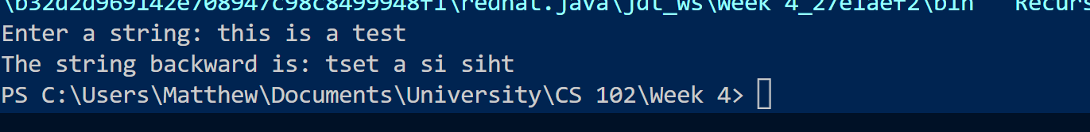

4. Summarize. The client is inquiring what is the program going to do. Let that person know in just a few sentences. (10 Points)

This program will take in a string and reverse it, just like you are reading it backwards

5. Will there be a need for maintenance or any updates in the future? (5 Points)

Not really unless you reach a string limit

6. Is there a need to train anyone to run this program? Answer in a few sentences. (5 Points)

There shouldnt be other than a quick explanation that it reverses the text